lu|g ;f];fOl6 klAns :s"n
jflif{s k/LIff– @)*@
sIff– g;{/L k"0f{fª\sM %)
ljifoM g]kfnL -df}_ pQL{0ffª\sM !*
gd:t] ¤ ;Gr} x'g'x'G5 <
!= tkfO{+sf] gfd s] xf] < %

@= tkfO{+ slt jif{sf] x'g' eof] < %

#= tkfO{+sf] sIff lzIfssf] gfd s] xf] < %

$= tkfO{+sf] k|wfgfWofkssf] gfd s] xf] < %

%= xfd|f] /fli6«o hgfj/sf] gfd s] xf] < %

^= tkfO{+nfO{ dgkg]{ /ªsf] gfd eGg'xf];\ . %

&= tnsf] cIf/x? eGg'xf];\ < !)
c cf O O{ p pm
C P P] cf]

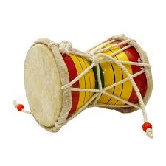
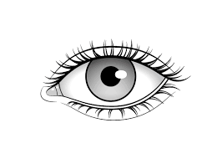
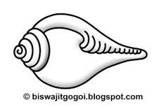
*= tnsf] lrqx?sf] gfd eGg'xf];\ . %


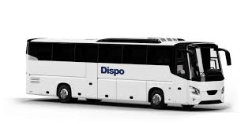

Green Society Public School
Annual Examination- 2082
Class: Nursery F.M.: 50
Sub: Rhymes and Conv. P.M.: 18
Hello! Good Morning/Good Afternoon
1. What is your name? 5

2. How old are you? 5

3. What is your principal's name? 5

4. What is your class teacher's name? 5

5. Identify the pictures? 5


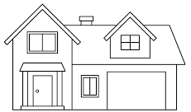

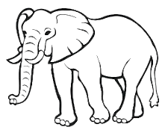


6. Rhymes. 5
7. Dance. 5
8. Neat and Clean. 5
9. Regularity. 5

Green Society Public School
Annual Examination- 2082
Class: Nursery F.M.: 50
Sub: English 'W' P.M.: 18

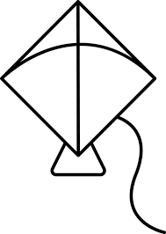
1. Match the letters with the correct pictures. 5

B
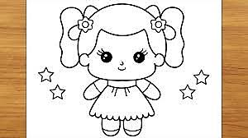
K
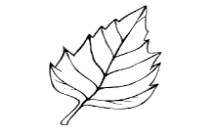
L
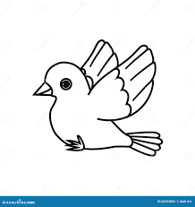
D
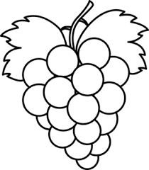
G
P
2. Colour the capital letters. 5
M m b T
a r Q i l
A e n Z
3. Copy the same letters. 6
a b c d e f

4. Match the same capital letters with small letters. 5
F j
J f
O z
S o
Z s
5. Circle the same letters. 5
Aa- Aa Bb Cc
Ee- Ff Ee Gg
kk- Jj Ii kk
Pp- Pp Oo Qq
Ww- Tt Ww Uu
6. Copy down the words. 6
Ant Bus Cat

7. Write the missing letters. 12
A D F
G J k
M N P Q R
U W
Y

8. Colour the picture. 5

Green Society Public School
Annual Examination- 2082
Class: Nursery F.M.: 50
Sub: Maths 'W' P.M.: 18

1. Count and circle the numbers. 5

: 8 7 2
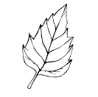









: 11 10 9

: 5 16 13






: 12 6 15
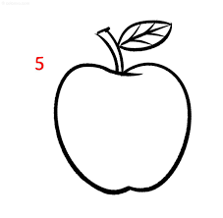






: 7 4 3

2. Match the number with numbers name. 5
1 Five
5 One
4 Two
10 Four
2 Ten
3. Write the Devanagari numbers (!%–@)_. 5
!%
4. What comes after? 6
2 10 21
29 14 9
5. Circle the Devanagari number of '!*'. 5
!* !*
( # !* *
!* !*
%

6. Count and write. 5

:

:
:

:





:

7. Write the missing numbers. 7
1 4, 5 7
9 12
14, 15.




8. Colour the odd one pictures. 5
1.
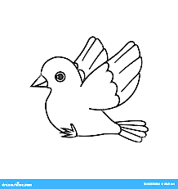
2.
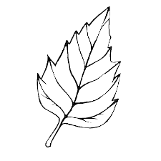
3.
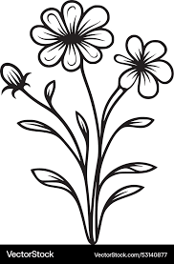

4.

5.
9. Match the same shapes. 3

10. Write the numbers name. 4
1: 2:

Green Society Public School
Annual Examination- 2082
Class: Nursery F.M.: 50
Sub: English 'Oral' P.M.: 18
Hello! Good Morning/Good Afternoon
How are you?
1. What is your name? 5

2. How old are you? 5

3. What is your class teacher's name? 5

4. What is your incharge's name? 5

5. What is your principal's name? 5

6. What is our national animal's name? 5

7. Read the given letters. 10
Qq Rr Ss Tt Uu
Vv Ww Xx Yy Zz
8. Identify the pictures. 5
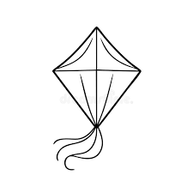
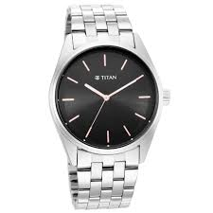

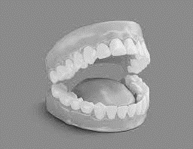


9. Neat and clean. 10

lu|g ;f];fOl6 klAns :s"n
jflif{s k/LIff– @)*@
sIff– g;{/L k"0f{fª\sM %)
ljifoM g]kfnL -lnlvt_ pQL{0ffª\sM !*

!= cIf/nfO{ qmd;Fu hf]8\g'xf];\ . %
s 3 ª
v u r


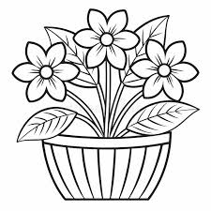
@= lrqsf] klxnf] cIf/ n]Vg'xf];\ . ^

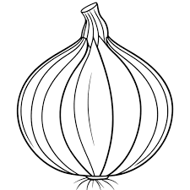
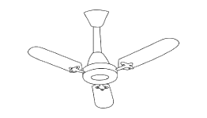


#= lrq / cIf/sf lardf hf]8f ldnfpg'xf];\ . %
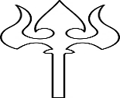
v

q
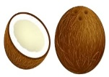
km

g
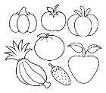
5

$= p:t} cIf/nfO{ ;fg'{xf];\ . %
c cf O O{ p pm

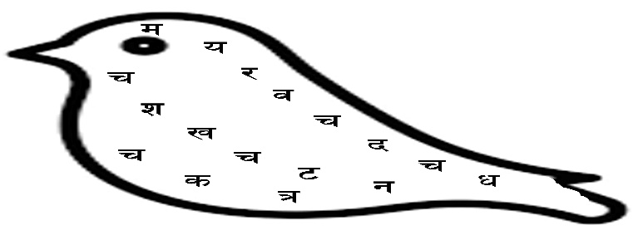
%= ærÆ cIf/df uf]nf] - _ 3]/f nufpg'xf];\ . %

^= vfnL 7fpF eg'{xf];\ . !#
v 3 ª r em
` 7 9 0f y b w
k km e d o n
z if x If 1 .
&= cIf/;Fu hf]8f ldnfpg'xf];\ . %
a; 6k
6k a;
du /ª
/ª rs
rs du

*= p:t} zAbnfO{ ;fg'{xf];\ . #
sk dn rn


(= tnsf] lrqdf /ª eg'{xf];\ . @

Green Society Public School
Annual Examination- 2082
Class: Nursery F.M.: 50
Sub: Maths 'Oral' P.M.: 18
Hello! Good Morning/Good Afternoon
How are you?
1. What is your name? 5

2. How old are you? 5

3. How many students are there in your classroom? 5

4. How many members are there in your family? 5

5. Say (20 to 30). 10
6. Say (!) – @)). 10
7. Read the following numbers? 5
25 26 27 28 29 30

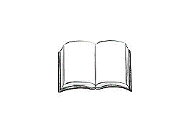
8. Identify the pictures. 5


